PROTECTION AND PERMANENCY MEMORANDUM, 14-07

TO: Service Region Administrators
Service Region Administrator Associates
Service Region Clinical Associates
Regional Program Specialists
Family Services Office Supervisors

FROM: Tina Webb, Assistant Director
Division of Protection and Permanency

DATE: September 8, 2014

SUBJECT: Duplication of Information Entered into TWIST

Following the state’s most recent NCANDS submission, our federal oversight agency identified duplicate reports of child abuse and neglect where the records had the same victim, alleged perpetrator and incident. TWIST personnel reviewed each duplicate record and determined that some regions are deliberately duplicating reports in TWIST in two or more cases. The most prevalent reasons for deliberate duplication are:
- Divorced parents; and
- Facility investigations that involve multiple perpetrators.
Duplication of investigations provides a false count of reports for any reporting. The same referral should never be entered in multiple cases. New reports should be entered only once and in accordance with SOP sections 2.1 Receiving and Assigning the Report and 2.2 Receiving a Specialized Investigation Report, and also in accordance with the Case Naming Protocol Tip Sheet.

Duplication of investigations is completely unnecessary. Any substantiation history for perpetrators and alleged victims can be located if the worker is conducting a thorough search. When searching, the SSW should follow the process below.

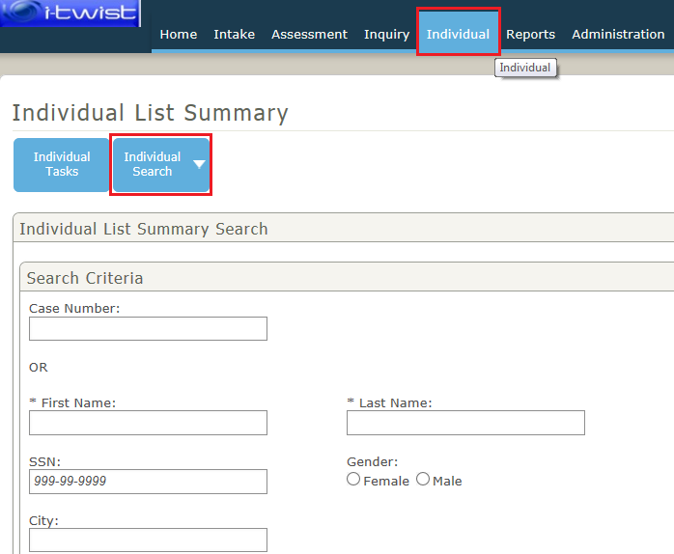
- The SSW first completes an individual search in iTWIST, by first clicking on “Individual,” then clicking the “Individual Search” button and completing the information requested on the screen (see screen shot below):

- After completing the individual search, click on the “Individual Id” for the person you are searching for:
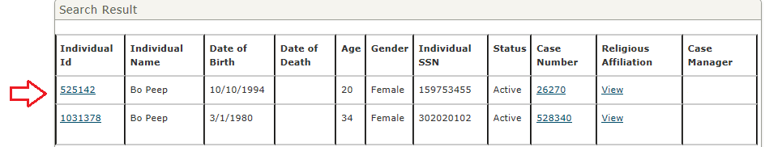

- This creates the “Individual Summary Face Sheet,” which provides information on all intakes and assessments for which the person has been involved. This function pulls information across all cases in the system.
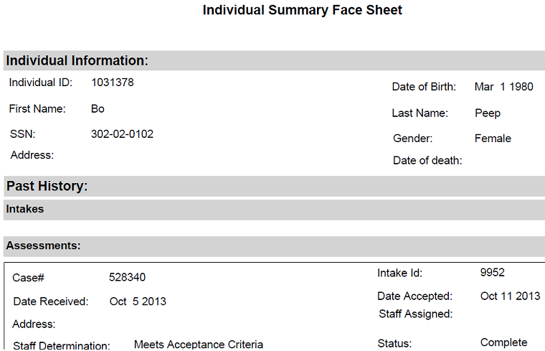

Please ensure to avoid duplication of report information in iTWIST. If you have any questions regarding this memorandum, please contact: Gretchen Marshall, Quality Assurance and Policy Development Branch Manager at Gretchen.marshall@ky.gov or (502) 564-7635, ext. 3587.

